Daily Accruals
Calculation Check
Row: 28 MAR 2025 – 29 MAR 2025
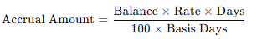
- Balance = 12000 SAR
- Days = 17
- Rate = 21.40%
- Basis = E ⇒ 365 days
- Shown Accrual = 119.63 SAR
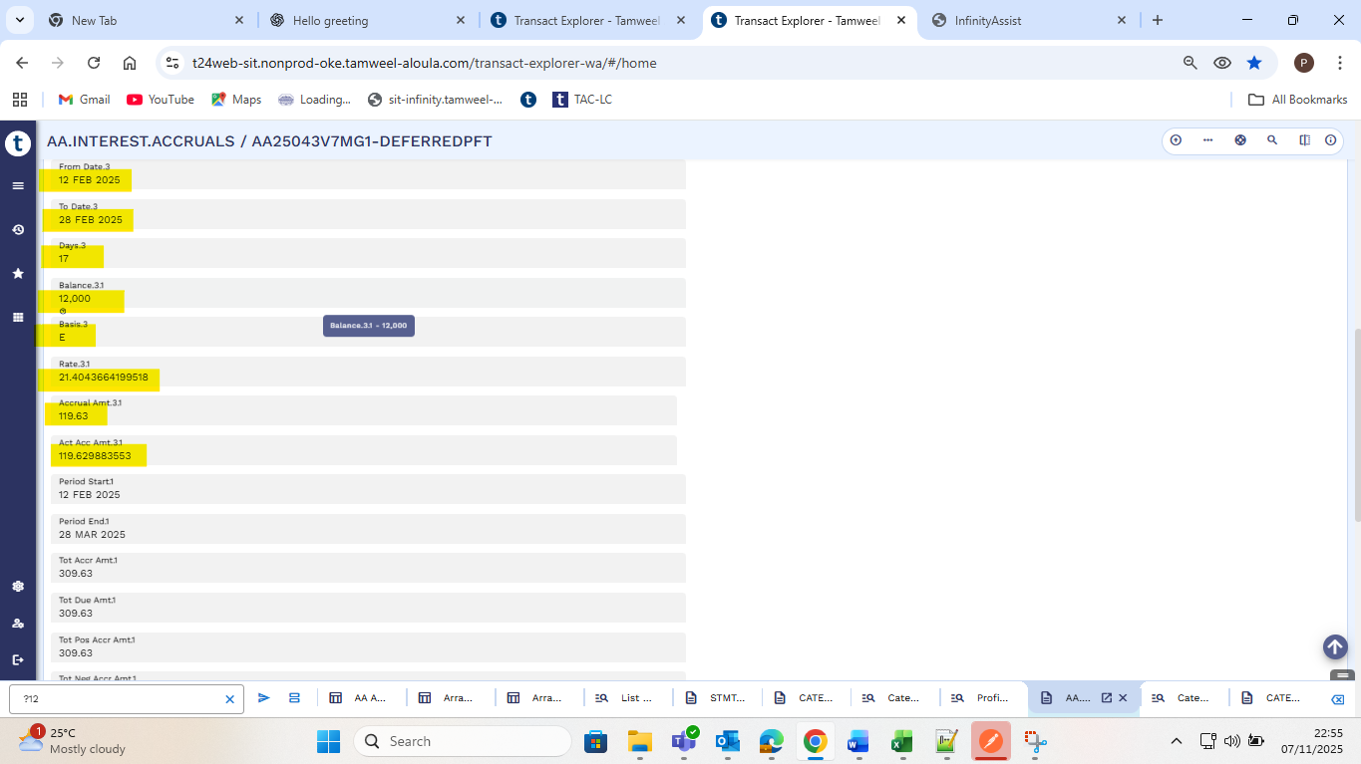

Calculation Check
Row: 28 MAR 2025 – 29 MAR 2025
- Balance = 12000 SAR
- Days = 27
- Rate = 21.40%
- Basis = E ⇒ 365 days
- Shown Accrual = 189.95 SAR ≈ 190 SAR
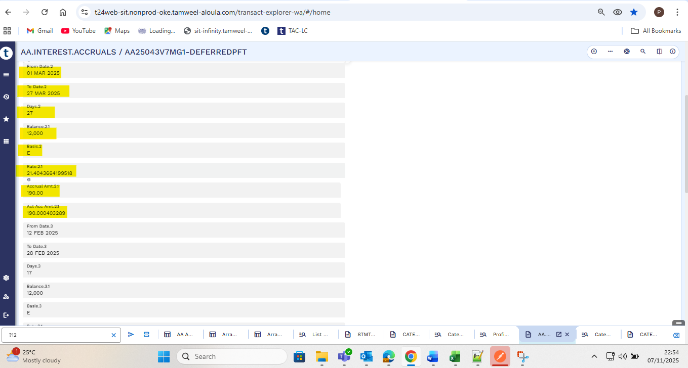

Arrangement Start date to installment date
Date = 12 FEB 2025 to 27 MAR 2025
- Balance = 12000 SAR
- Days = 44
- Rate = 21.40%
- Basis = E ⇒ 365 days
- Shown Accrual = 309.63 SAR
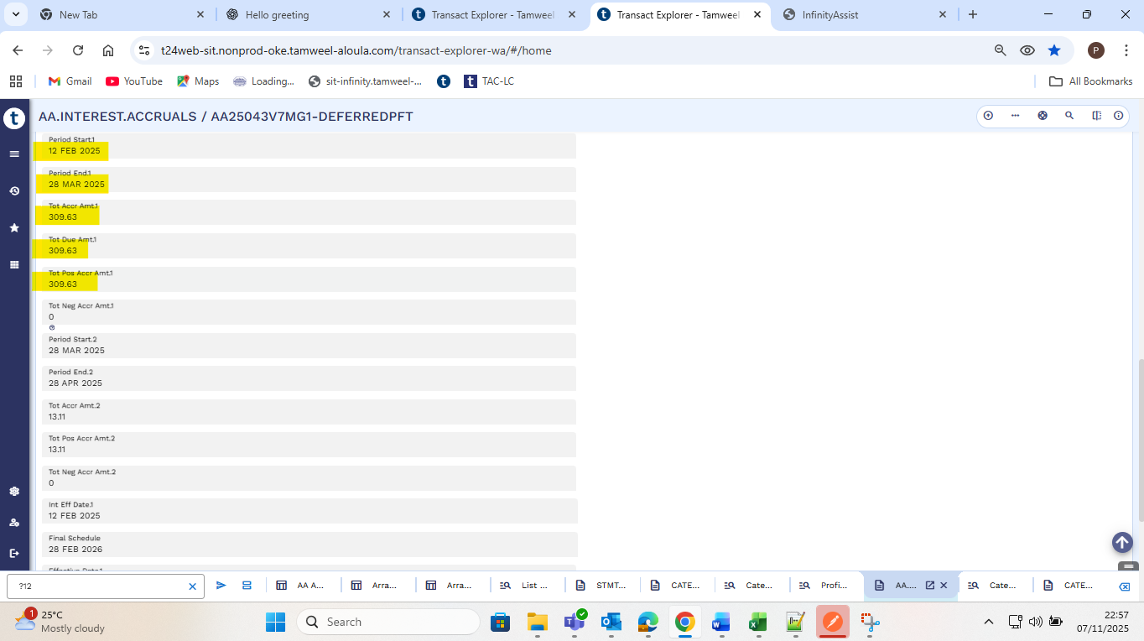

Interest Accruals:
After 2 days of the 1st Installment
Calculation Check
Row: 28 MAR 2025 – 29 MAR 2025
- Balance = 11,180.52 SAR
- Days = 2
- Rate = 21.40%
- Basis = E ⇒ 365 days
- Shown Accrual = 13.11 SAR
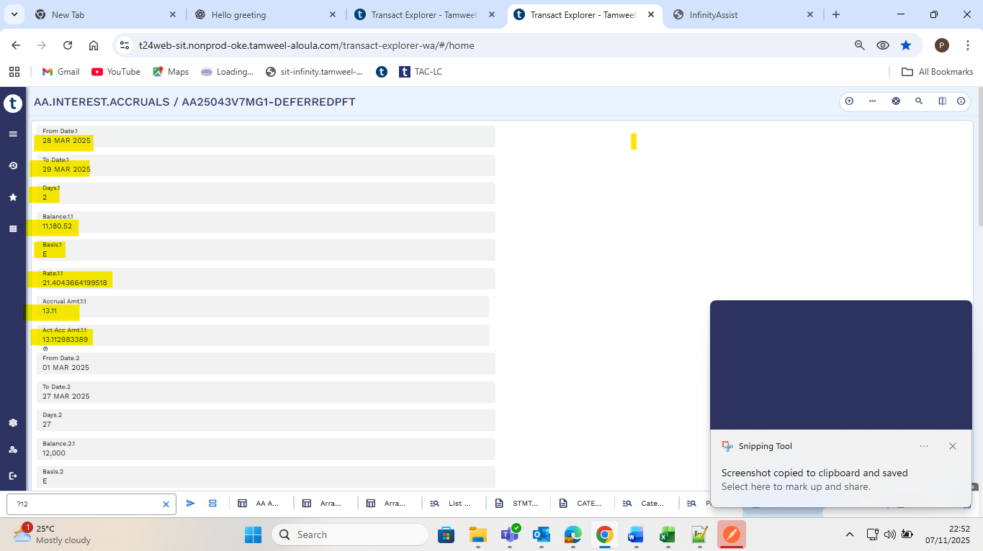

Daily Accruals
Daily Amortization Profit based on reducing balance
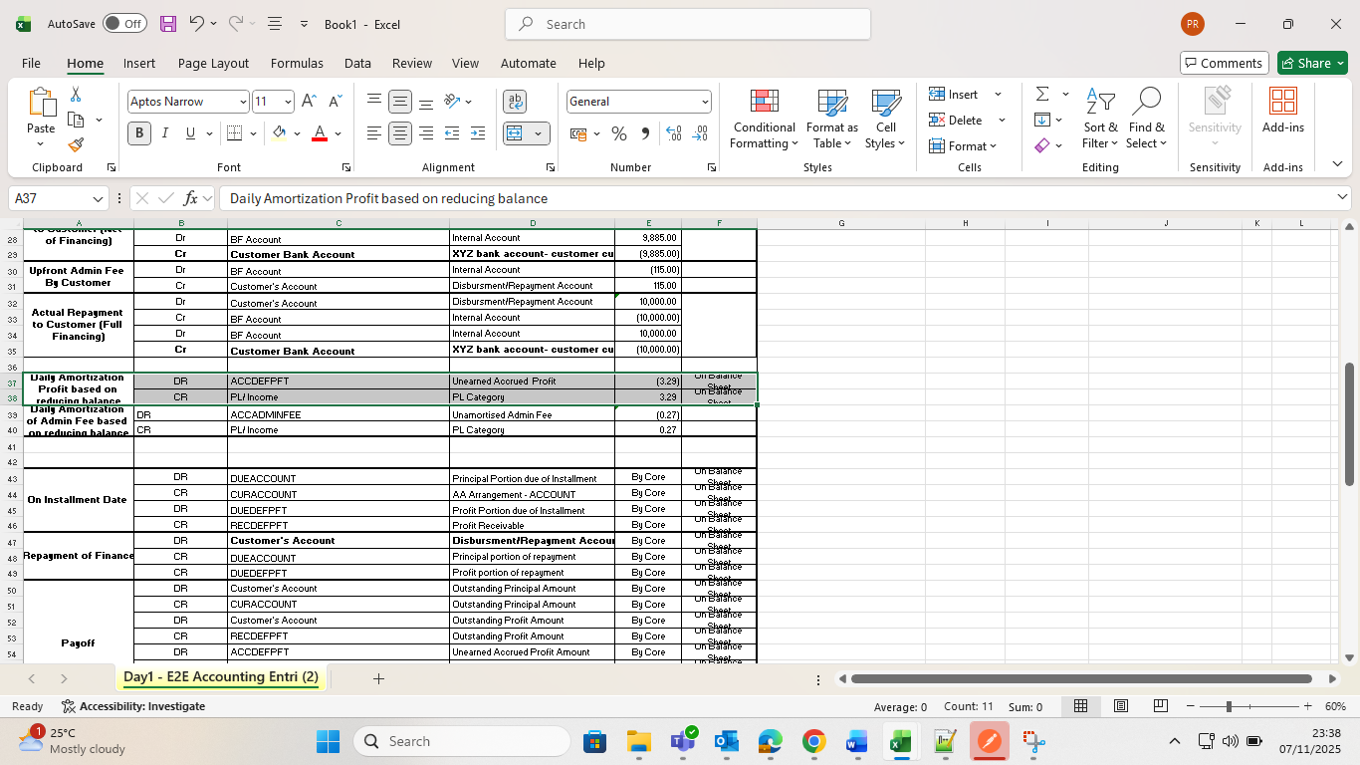

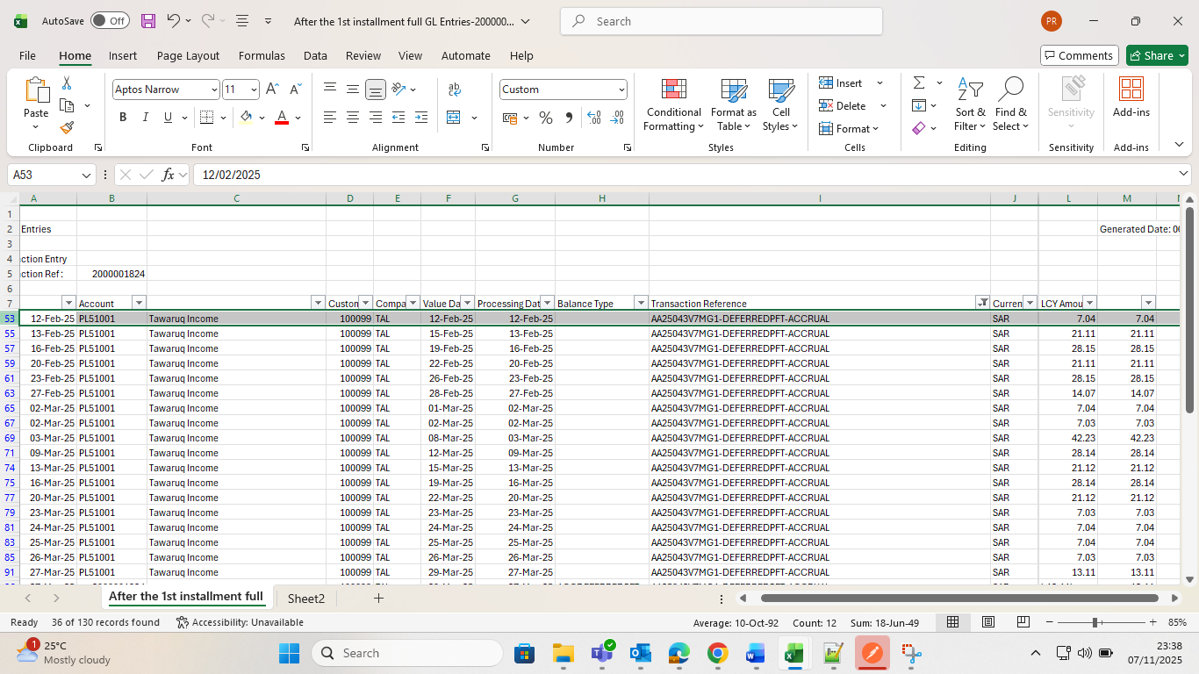

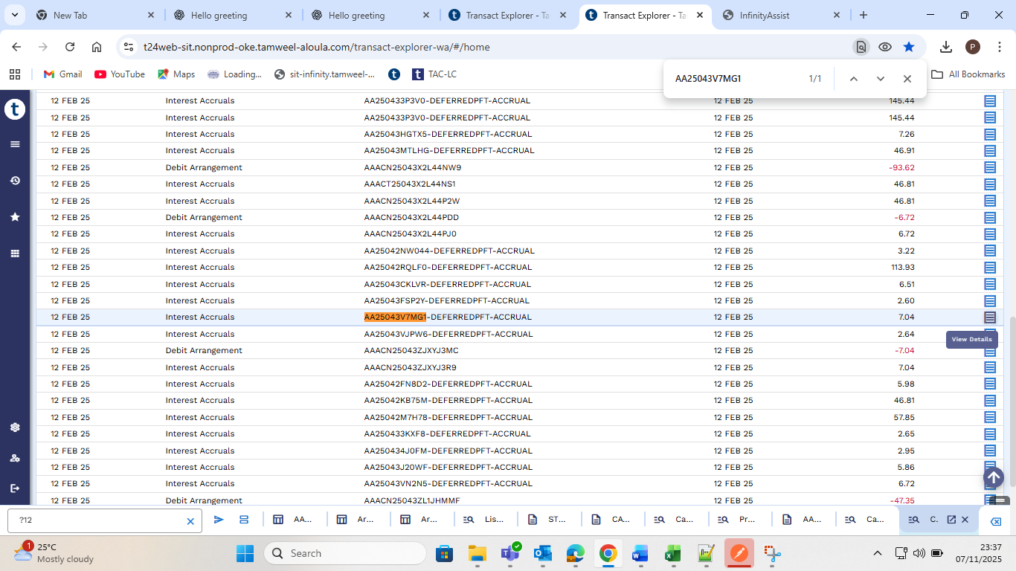

Daily Amortization of Admin Fee based on reducing balance
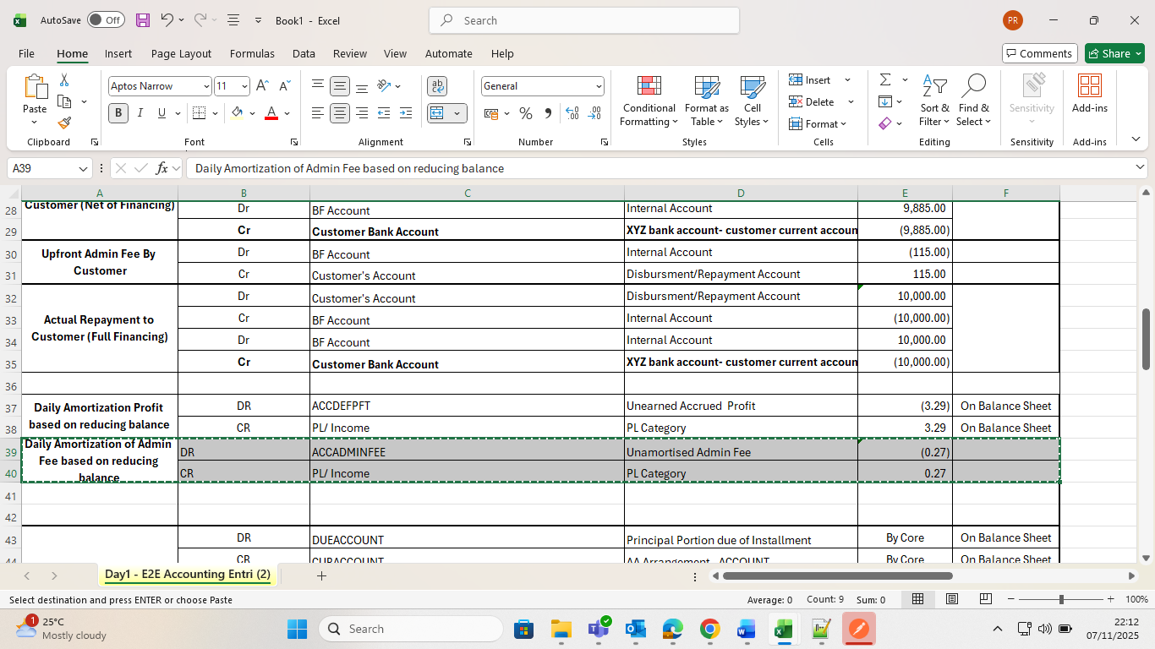
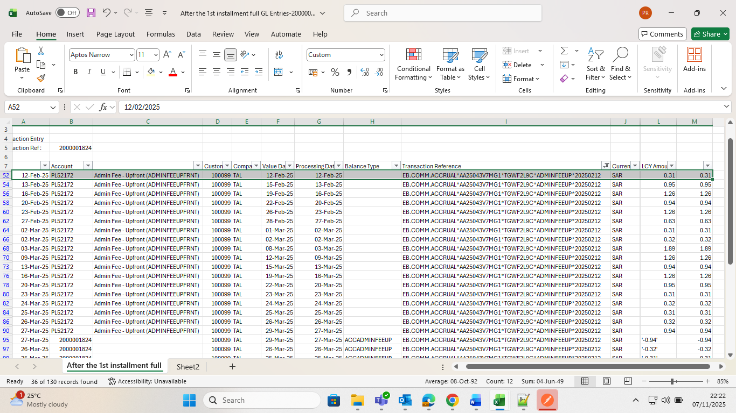
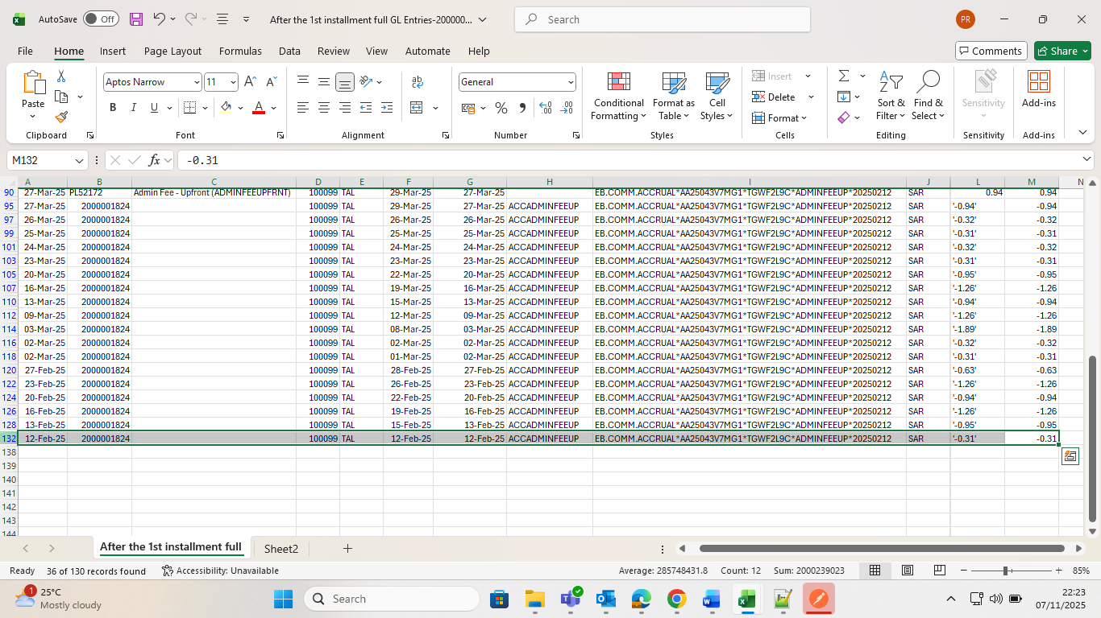

PL – Entry for Accruals
